Simon kuznets kharkiv national university of economics

Student name: Abdullayev Mahammadaga
Group number: 6.46.121.010.23.1
Teacher: Volodymyr Aleksiyev

Laboratory work 3

In order to download juice shop, I installed it using Docker
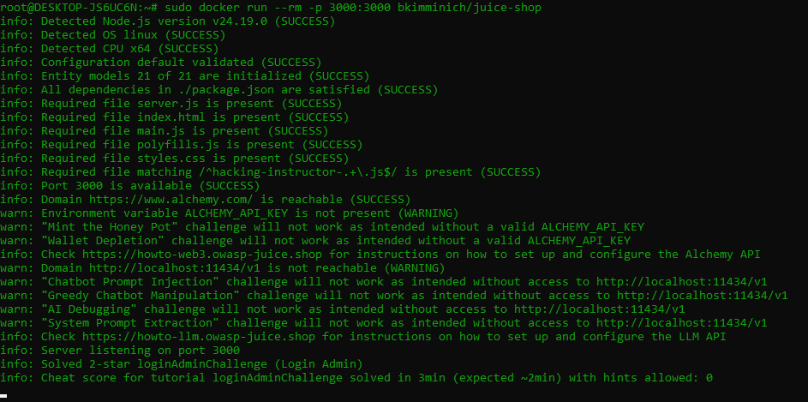

Test Analysis: Exploiting XSS via <img> Tag
Mechanism: This payload utilizes an <img> tag with an intentionally invalid source (src=x). Because the browser fails to load the image, it immediately triggers the onerror event handler, executing the embedded JavaScript code (alert(document.domain)).
Test Result: The appearance of a pop-up window displaying the localhost domain name on the search results page confirms that the application improperly handles and reflects user-supplied input, verifying the presence of a Reflected XSS vulnerability.
<img src=x onerror=alert(document.domain)>
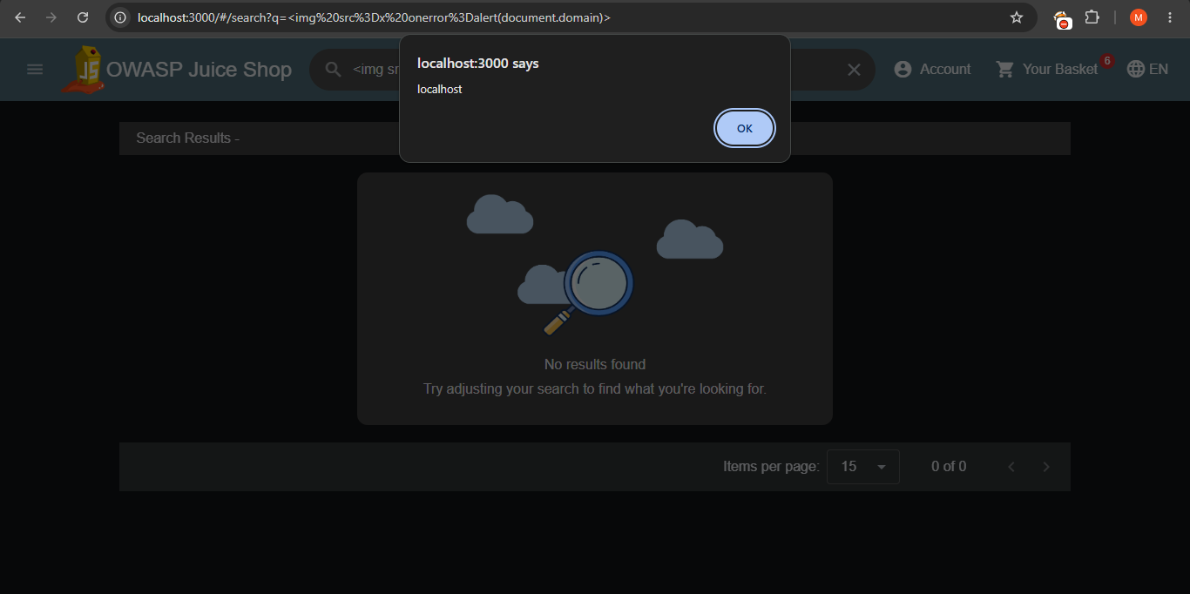

Exploit Analysis: XSS via <iframe> Tag
Mechanism: This payload leverages an <iframe> tag containing a JavaScript URI scheme (javascript:...) within its src attribute. As the browser constructs and loads the inline frame, it executes the embedded script directly.
Test Result: The appearance of a pop-up dialog box displaying "XSS" on the search results page proves that HTML attributes accepting URI schemes are unmitigated, confirming the presence of a Reflected XSS vulnerability.
<iframe src="javascript:alert('XSS')"></iframe>
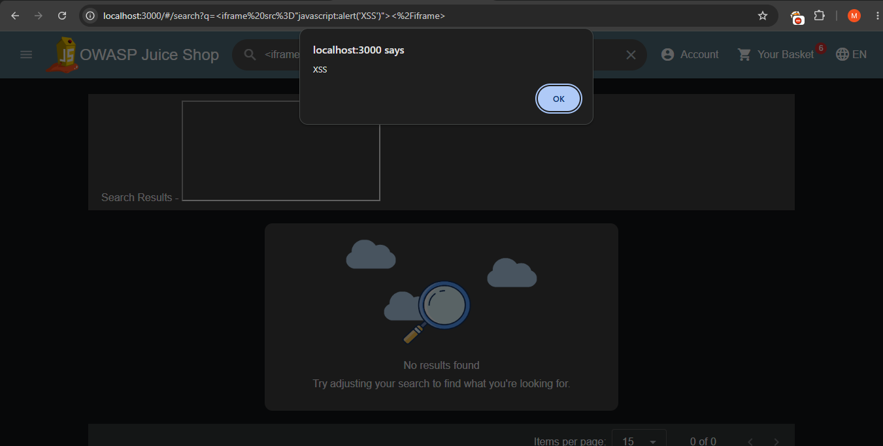

Exploit Analysis: XSS via <input> Tag
Mechanism: This payload utilizes an <input> element with the autofocus attribute, which automatically focuses on the element as soon as the page loads. This action immediately triggers the onfocus event handler, executing the embedded JavaScript alert(1).
Test Result: The appearance of a pop-up window displaying 1 on the search results page proves that interactive input attributes can successfully serve as vectors for Reflected XSS vulnerabilities
<input autofocus onfocus=alert(1)>
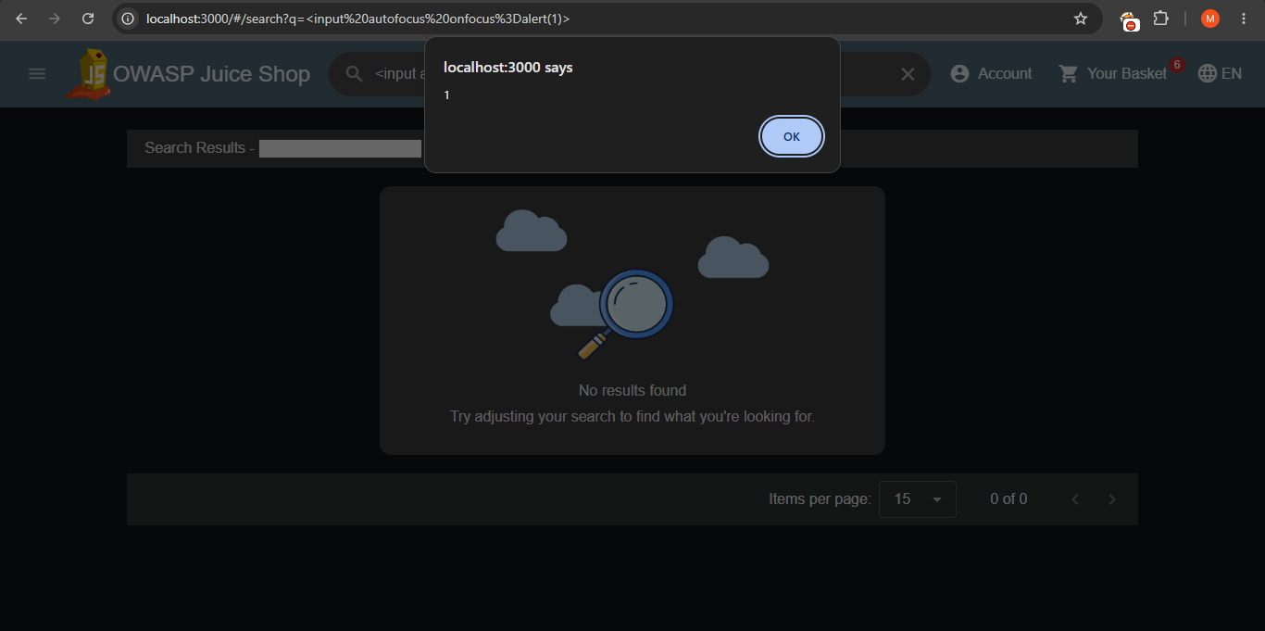

Exploit Analysis: XSS via <details> Tag
Mechanism: This payload leverages the HTML5 <details> element with the open attribute, which causes the element to be rendered in an expanded state upon loading. This state change triggers the ontoggle event handler, immediately executing the embedded JavaScript alert(1).
Test Result: The appearance of a pop-up window displaying 1 on the search results page demonstrates that HTML5 disclosure elements and toggle event handlers can successfully bypass filters and serve as vectors for Reflected XSS vulnerabilities.
<details open ontoggle=alert(1)>
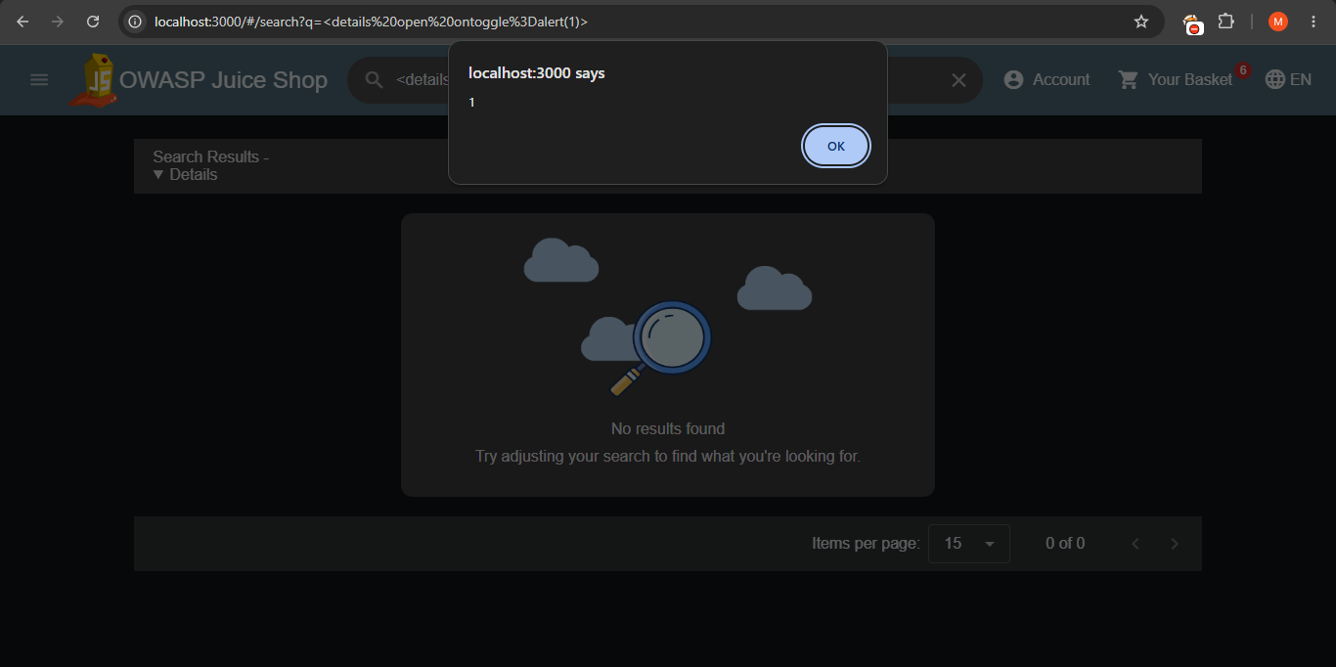

Mitigation Strategies for Cross-Site Scripting (XSS)
To effectively mitigate Reflected and Stored XSS vulnerabilities within an application's source code, developers must implement a defense-in-depth strategy incorporating secure coding practices:
- Context-Aware Output Encoding: Ensure that all user-supplied data rendered in the application view is properly encoded. Special characters (such as <, >, &, ", and ') must be converted into their safe HTML entity counterparts so the browser treats them strictly as text rather than executable markup. Modern frontend frameworks (like Angular or React) handle this by default, but developers must avoid bypassing built-in sanitization mechanisms (e.g., using innerHTML or unsafe bindings).
- Strict Input Validation and Sanitization: Implement allowlist-based input validation on both the client and server sides to reject unexpected characters or formats. If user-generated HTML or rich text is permitted, utilize reputable sanitization libraries (such as DOMPurify or sanitize-html) to strip out dangerous tags (<script>, <iframe>, <object>) and event handlers (onerror, onload, onfocus) before storage or rendering.
- Content Security Policy (CSP): Deploy a robust CSP HTTP response header. A well-configured CSP restricts the sources from which scripts can be loaded, disables inline script execution (unsafe-inline), and restricts domain execution, significantly mitigating the impact of any injected XSS payloads.
- Secure Cookie Management: Protect sensitive user tokens and session identifiers by setting the HttpOnly, Secure, and SameSite flags on cookies. This prevents malicious scripts from accessing session data via document.cookie in the event of an XSS compromise.

